FORNAX™ ePlanCheck Rule
Rule Information
Rule ID | WTR 6.8.1
Rule Name | Water Used for Fire Fighting Purposes
Chapter | 2 Distribution
Section | 2.8 Fire-Fighting Services
Handbook | Code of Practice for Water Services  Incorporating Amendment No. 1 - 4 – CP 48 : 2005

Rule Description
6.8.1 Water requirements for fire fighting purposes should not be stored in potable water storage tanks, unless arrangements are made in the design, to be approved by the Authority that the combined storage will not cause stagnation and/or contamination to the water stored.

Rule Interpretation
- This rule checks for the water used for firefighting purposes which should not be stored in potable water storage tanks.
- Water pipe from PUB Mains shall be called “Service Pipe” and pipes coming from Water Storage Tank shall be called “Distribution pipe”.
- There should be no pipe line designated for firefighting purposes that is connected directly from the water storage tank or in the distribution pipe.
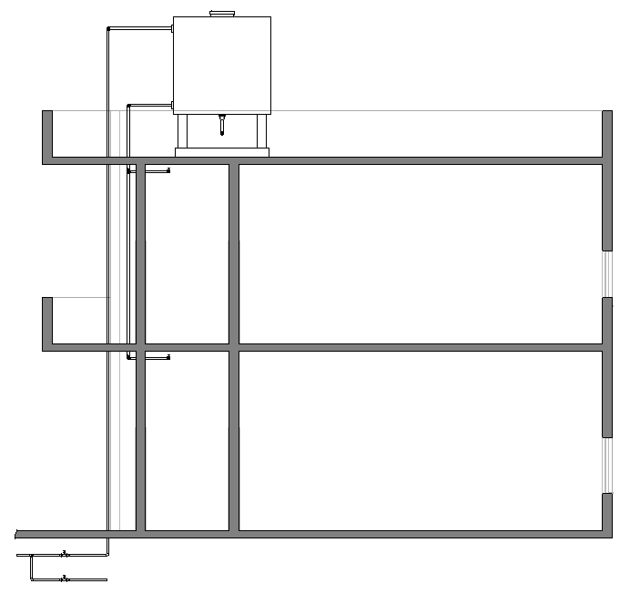
POTABLE WATER STORAGE TANK

Roof Deck

Level 02

Level 01

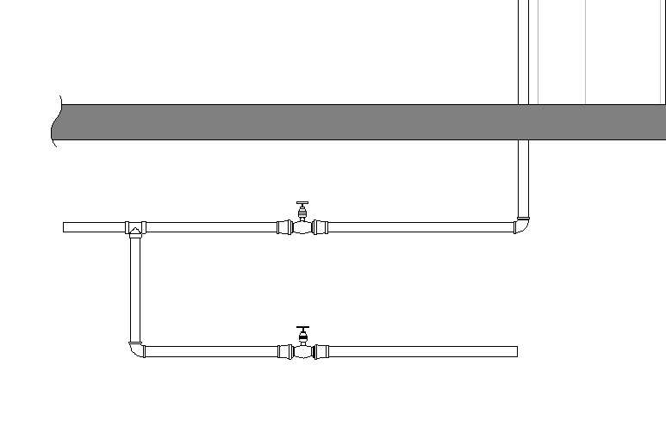
SERVICE PIPE GOING TO POTABLE WATER STORAGE TANK

FROM PUB MAINS

TO FIRE FIGHTING SERVICES

Water Used for Fire Fighting Purposes
FIGURE 01

Rule Scenario

Scenario 01 – Compliant 1
Requirement | Water used for firefighting purposes should not be stored in potable water storage tank.
Description | Water pipe used for firefighting purposes is connected from the service pipe going from the PUB Mains.
POTABLE WATER STORAGE TANK

Roof Deck

Level 02

Level 01

SERVICE PIPE GOING TO POTABLE WATER STORAGE TANK

FROM PUB MAINS

TO FIRE FIGHTING SERVICES

SECTION
FIGURE SCENARIO

Scenario 01 – Compliant 2
Requirement | Water used for firefighting purposes should not be stored in potable water storage tank.
Description | Water pipe used for firefighting purposes is connected to separate (Firefighting) Water Storage Tank.
POTABLE WATER STORAGE TANK
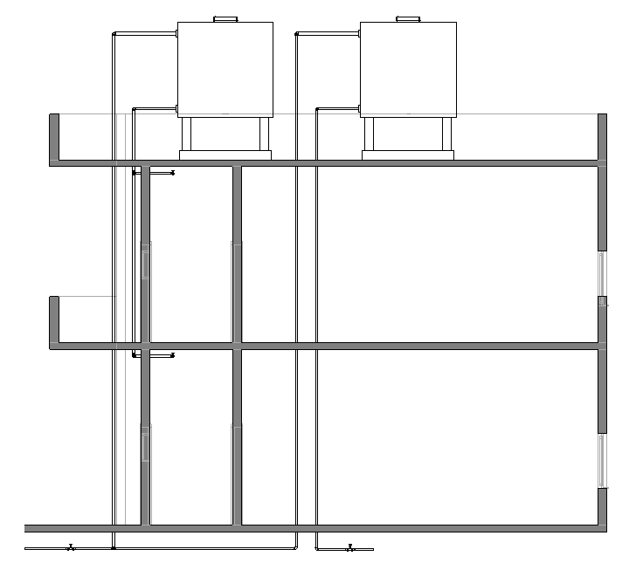
FIREFIGHTING WATER STORAGE TANK

Roof Deck

Level 02

Level 01
DISTRIBUTION PIPE COMING FROM FIREFIGHTING WATER STORAGE TANK

FROM PUB MAINS
TO FIRE FIGHTING SERVICES

SECTION
FIGURE SCENARIO

Scenario 01 – Non-Compliant 1
Requirement | Water used for firefighting purposes is stored in potable water storage tank.
Description | Distribution pipe for firefighting services that is connected from the water storage tank is provided.
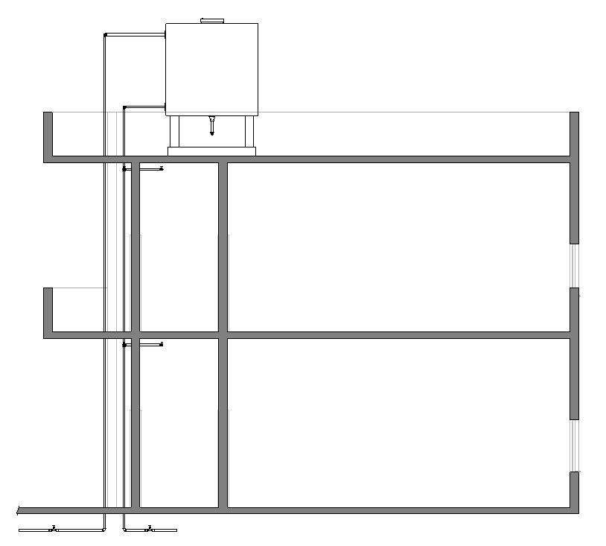

POTABLE WATER STORAGE TANK

Roof Deck

Level 02

Level 01

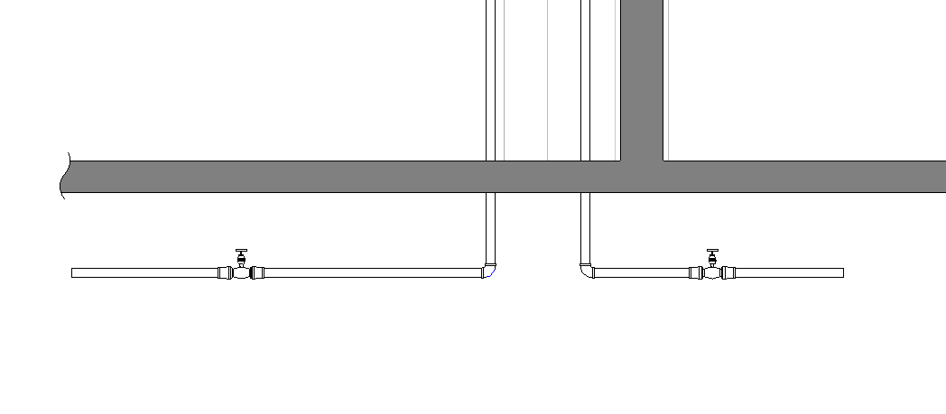
DISTRIBUTION PIPE COMING FROM POTABLE WATER STORAGE TANK

TO FIRE FIGHTING SERVICES
FROM PUB MAINS

SECTION
FIGURE SCENARIO

Scenario 01 – Non-Compliant 2
Requirement | Water used for firefighting purposes is stored in potable water storage tank.
Description | Distribution pipe for firefighting services is connected to a combined potable/firefighting water storage tank.
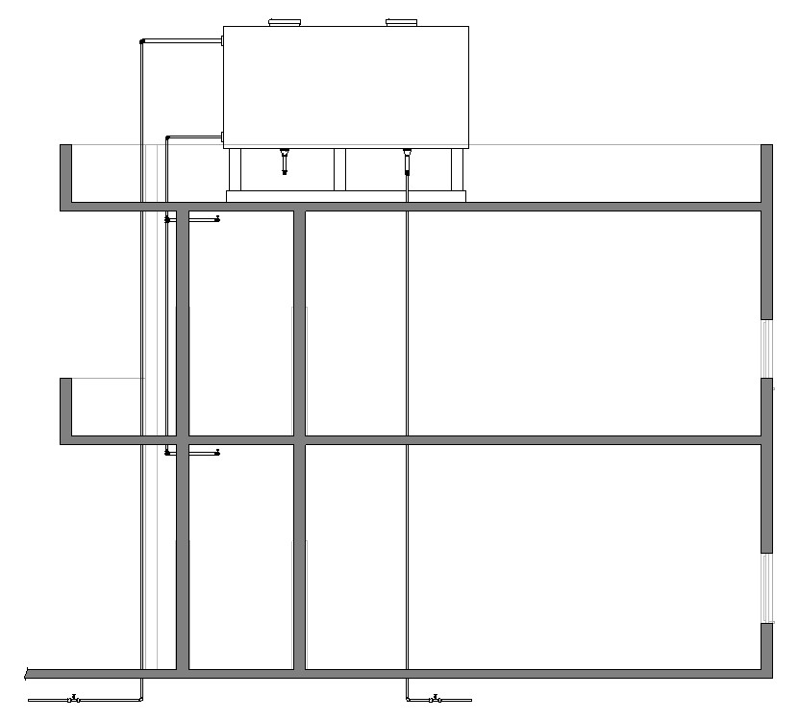
COMBINED POTABLE/FIREFIGHTING WATER STORAGE TANK

Roof Deck

Level 02

Level 01
DISTRIBUTION PIPE COMING FROM COBINED WATER STORAGE TANK

FROM PUB
MAINS
TO FIRE FIGHTING SERVICES

SECTION
FIGURE SCENARIO

Request For Information
- The Rule ID WTR 6.8.1 stated in 24_Appendix 2_COP rules.pdf does not exist in IBS_PUB-CP 48-2005+Amd 1&2.pdf

- The clause state in 24_Appendix 2_COP rules.pdf actually directs to WTR 2.8.1. Is this correct?

Model PreCheck

Required Elements | Required Attributes
PipeSegment | IfcDescription contains “Firefighting Service”
PipeSegment | IfcDescription contains “Firefighting Distribution”
PipeSegment | IfcDescription contains “Service”
PipeSegment | IfcDescription contains “Distribution”
FlowStorageDevice | IfcName contains “Potable Water Storage Tank”
FlowStorageDevice | IfcName contains “Fire-fighting Water Storage Tank”
FlowStorageDevice | IfcName contains “Combined Water Storage Tank”

Rule Parameters

System Type
Cold Water |  | 
Hot Water
 | Sanitary
 | Sewerage
Vent

Element Type 1
State | Type | Property | Operator | Value
Include | PipeSegment | IfcDescription | Contains | Firefighting Service
Exclude |  | Any | Match | N.A.
 |  |  | N.A. | <User defined>

Element Type 2
State | Type | Property | Operator | Value
Include | PipeSegment | IfcDescription | Contains | Firefighting Distribution
Exclude |  | Any | Match | N.A.
 |  |  | N.A. | <User defined>

Element Type 3
State | Type | Property | Operator | Value
Include | PipeSegment | IfcDescription | Contains | Distribution
Exclude |  | Any | Match | N.A.
 |  |  | N.A. | <User defined>

Element Type 4
State | Type | Property | Operator | Value
Include | PipeSegment | IfcDescription | Contains | Service
Exclude |  | Any | Match | N.A.
 |  |  | N.A. | <User defined>

Element Type 5
State | Type | Property | Operator | Value
Include | FlowStorageDevice | IfcName | Contains | Potable Water Storage Tank Tank
Exclude |  | Any | Match | N.A.
 |  |  | N.A. | <User defined>

Element Type 6
State | Type | Property | Operator | Value
Include | FlowStorageDevice | IfcName | Contains | Combined Water Storage Tank Tank
Exclude |  | Any | Match | N.A.
 |  |  | N.A. | <User defined>

Element Type 7
State | Type | Property | Operator | Value
Include | FlowStorageDevice | IfcName | Contains | Firefighting Water Storage Tank Tank
Exclude |  | Any | Match | N.A.
 |  |  | N.A. | <User defined>

Element Type 1 Condition
* Should not be connected to Element Type 5
* Should not be connected to Element Type 6
* Should be connected to Element Type 4
* Should be connected to Element Type 7

Element Type 2 Condition
* Should not be connected to Element Type 3
* Should not be connected to Element Type 5
* Should not be connected to Element Type 6
* Should be connected to Element Type 7

Result Messages
- 6.8.1 Water Used for Fire Fighting Purposes
  - Non-Compliant (TotalResultNumeric)
    - BuildingStorey (TotalResultPerFloorNumeric)
  - ElementName(Type2)Numeric: Connected to ElementName(Type3)Numeric
  - ElementName(Type2)Numeric: Connected to ElementName(Type6)Numeric
  - Compliant (TotalResultNumeric)
    - BuildingStorey (TotalResultPerFloorNumeric)
  - ElementName(Type1)Numeric: Connected to ElementName(Type4)Numeric
  - ElementName(Type1)Numeric and ElementName(Type2)Numeric: Connected to ElementName(Type7)Numeric

Sample Result Messages
- 6.8.1 Water Used for Fire Fighting Purposes
  - Non-Compliant (2)
    - Basement 01 (1)
    - Firefighting Distribution Pipe 103.1: Connected to Distribution Pipe 103
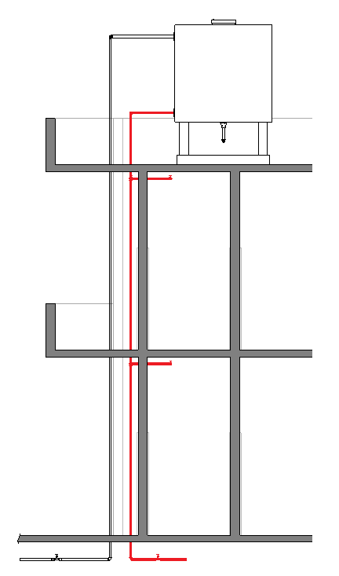

SECTION

    - Basement 01 (1)
    - Firefighting Distribution Pipe 203.1: Connected to Combined Water Storage Tank 203
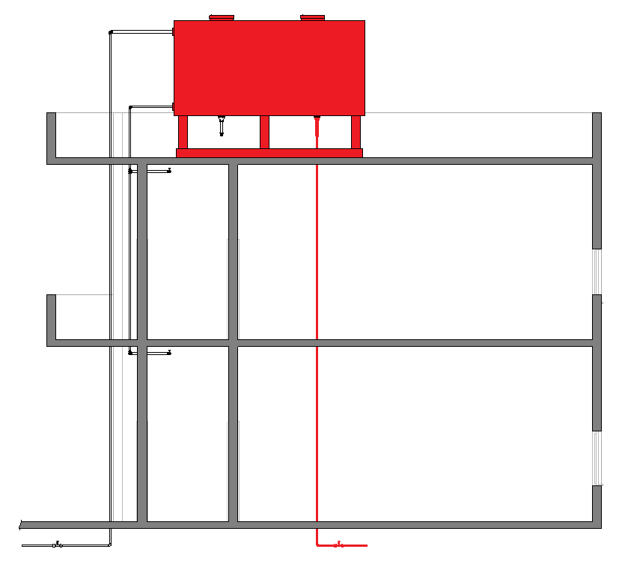

SECTION

  - Compliant (2)
    - Basement 01 (1)
    - Firefighting Service Pipe 303.3: Connected to Service Pipe 303
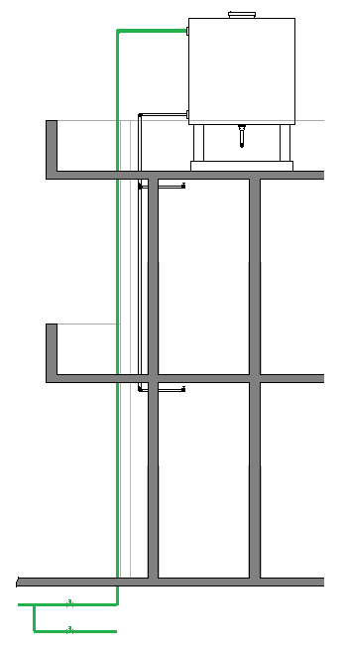

SECTION
- Basement 01 (1)
    - Firefighting Service and Firefighting Distribution Pipe 403.3: Connected to Firefighting Water Storage Tank 403
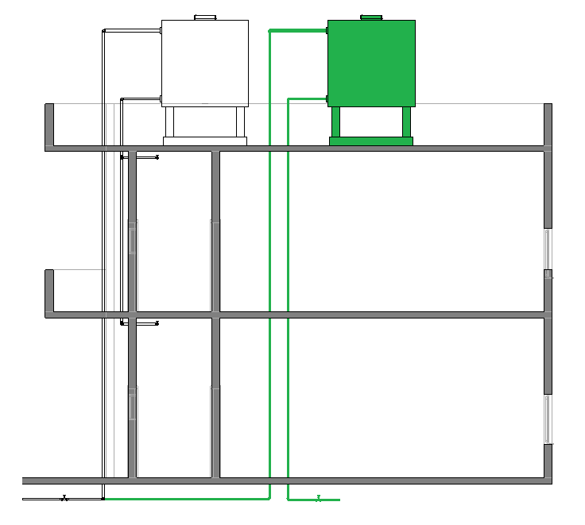

SECTION

Sample Result Model Views
- 6.8.1 Water Used for Fire Fighting Purposes
- Non-Compliant
- Section view.
    - Highlight checked element/space.
    - All other elements are in translucent except checked element/space.
- Compliant
- Section view.
- Highlight checked element/space.
- All other elements are in translucent except checked element/space.

Testing Scenario Notes
- Scenario 01 – Non-Compliant 1
- Basement 01
- Distribution pipe for firefighting services is connected to a Water Storage Tank.

- Scenario 01 – Non-Compliant 2
- Basement 01
- Distribution pipe for firefighting services is connected to a combined Potable/Firefighting Water Storage Tank.

- Scenario 01 – Compliant 1
- Basement 01
- Water pipe used for firefighting purposes is connected from the service pipe coming from the PUB Mains.

- Scenario 01 – Compliant 2
- Ground Level
- Water pipe used for firefighting purposes is connected to a separate Water Storage Tank (for Firefighting).

Model:
WTR 6.8.1 Scenario 01 Non-Compliant 1.ifc
WTR 6.8.1 Scenario 01 Non-Compliant 2.ifc
WTR 6.8.1 Scenario 01 Compliant 1.ifc
WTR 6.8.1 Scenario 01 Compliant 2.ifc

Modelling Guideline
- Specify IfcDescription containing “Firefighting Service” for relevant PipeSegment.
- Specify IfcDescription containing “Firefighting Distribution” for relevant PipeSegment.
- Specify IfcDescription containing “Distribution” for relevant PipeSegment.
- Specify IfcDescription containing “Service” for relevant PipeSegment.
- Specify IfcName containing “Potable Water Storage” for relevant FlowStorageDevice.
- Specify IfcName containing “Firefighting Water Storage” for relevant FlowStorageDevice.
- Specify IfcName containing “Combined Water Storage” for relevant FlowStorageDevice.

Specification Log
RA | Reymart Sisgon
Last edit date | 29 October 2018
ePC version
Updates | - V1

